INTRODUCTION

Over-voltages occur in a system when the system voltage rises over 110% of the nominal rated voltage. There is always a chance for suffering of an electrical power system from abnormal over voltages. These abnormal over voltages may be caused due to various reason such as, sudden interruption of heavy load, lightening impulses, switching impulses etc. These over voltage stresses may damage insulation of various equipment’s and insulators of the power system. Although, all the over voltage stresses are not strong enough to damage insulation of system, but still these over voltages also to be avoided to ensure the smooth operation of electrical power system. The present work aims to develop an over voltage and over current relay for Domestic and small commercial electrical installations using ARDUINO at a cheaper cost.

OVER VOLTAGE

The word over voltage is in use from 1907. According to IEEE standards, Overvoltage is defined as: “Voltage between one phase and ground or between two phases, having a crest value exceeding the corresponding crest of maximum system voltage.” It can also be defined as the voltage in a circuit or part of it is raised above its upper design limit. Also an overvoltage is a voltage pulse or wave which is superimposed on the rated voltage of the network Figure

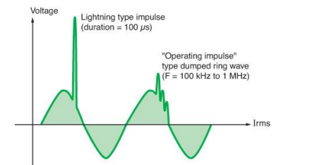

TYPES OF OVER VOLTAGES

Depending on the duration and the magnitude of the voltage, over voltages are classified into various types as follows:

EXTERNAL OVER VOLTAGES

This type of over voltages originates from atmospheric disturbances, mainly due to lightning. This takes the form of a surge and has no direct relationship with the operating voltage of the line. It may be due to any of the following causes:

1. Direct lightning stroke: A lightening stroke is defined as a direct stroke if it hits either the tower or shield wire or the phase conductor. When the insulator string flashes over by direct hit either to the tower or to the shield wire along the span, it is called back flash.
2. Electromagnetically induced over voltages due to lightning discharge taking place near the line are called 'side stroke'.
3. Voltages induced due to atmospheric changes along the length of the line
4. Electrostatically induced voltages due to presence of charged clouds nearby.

Electrostatically induced over voltages due to the frictional effects of small particles like dust or dry snow in the atmosphere or due to change in the altitude of the line

**Internal Over voltages:**

These over voltages are caused by changes in the operating conditions of the power system. These can be divided into two groups as below:

**1. Switching over voltages or Transient over operation voltages of high frequency:**

A short-duration highly damped, oscillatory, or non-oscillatory overvoltage, having duration of few milliseconds or less is Transient overvoltage. This is caused when switching operation is carried out under normal conditions or when fault occurs in the network. When an unloaded long line is charged, due to Ferranti Effect the receiving end voltage is increased considerably resulting in over voltage in the system. Similarly when the primary side of the transformers or reactors is switched on, over voltage of transient nature occurs.

**2. Temporary over voltages:**

An Oscillatory phase-to-ground or phase-to phase overvoltage that generally exists for long duration (seconds, even minute) and that is un-damped or only weakly damped is Temporary over voltage. Temporary overvoltage usually originate from switching operation or faults (e.g. load rejection, single-phase fault, fault on a high-resistance ground or ungrounded system) or from nonlinearities (Ferro resonance, harmonics), or both. They are characterized by the amplitude, the oscillation frequencies, the total duration or the decrement.

**CAUSES OF OVER VOLTAGES**

INTERNAL CAUSES: (I) switching surges: A surge, or transient, is a sub cycle overvoltage with a duration of less than a half-cycle of the normal voltage waveform. A surge can be either positive or negative polarity, can be additive or subtractive from the normal voltage waveform, and is often oscillatory and decaying over time. Surges, or transients, are brief overvoltage spikes or disturbances on a power waveform that can damage, degrade, or destroy electronic equipment within any home, commercial building, industrial, or manufacturing facility. Transients can reach amplitudes of tens of thousands of volts. Surges are generally measured in microseconds. Few cases of switching surges are discussed here.

(II) Insulation failure: Electrical breakdown or dielectric breakdown is a long reduction in the resistance of a 12 electrical insulator when the voltage applied across it exceeds the breakdown voltage. This results in the insulator becoming electrically conductive. Electrical breakdown may be a momentary event (as in an electrostatic discharge), or may lead to a discontinuous arc charge if protective devices fail to interrupt the current in a low power circuit. Under sufficient electrical stress, electrical breakdown can occur within solids, liquids, gases or vacuum. However, the specific breakdown mechanisms are significantly different for each, particularly in different kinds of dielectric medium. (III) Arcing ground: Arcing Grounds is a phenomenon which is observed in ungrounded three phase systems. In ungrounded three phase systems operating in a healthy balanced conditions, capacitances are formed between the conductors and ground. The voltage across these capacitances is the phase voltage. Now, in the event of a ground fault, the voltage across the faulty conductor becomes zero while the voltages across the healthy conductors increase by a factor of 1.732. The arc caused between the faulty conductor and the ground gets extinguished and restarts many times, this repeated initiation and extinction of the arc across the fault produces severe voltage oscillations of the order of nearly three to four times the nominal voltage. This repeated arcing across the fault due to the capacitances between the conductors and the ground is known as arcing grounds.

**EXTERNAL CAUSES:**

(I) Lightening: A lightning strike creates over voltages that propagate along any type of electrical cabling (electrical distribution mains, telephone connections, communication bus, etc.), metallic 13 wiring systems or conducting elements of significant length. The consequences of lightning, i.e. the over voltages created on the installations and equipment, can be appreciable over a radius of 10km. • Internal causes do not produce surges of large magnitude. • Experience shows that surges due to internal causes hardly increase the system voltage to twice the normal value. • Generally, surges due to internal causes are taken care of by providing proper insulation to the equipment in the power system. • However, surges due to lightning are very severe may increase the system voltage to several times the normal value. • If the equipment in the power system is not protected against lightning surges, these surges may cause considerable damage. • In fact, in a power system, the protective devices provided against overvoltages mainly take care of lightning surges.

BLOCK DIAGRAM

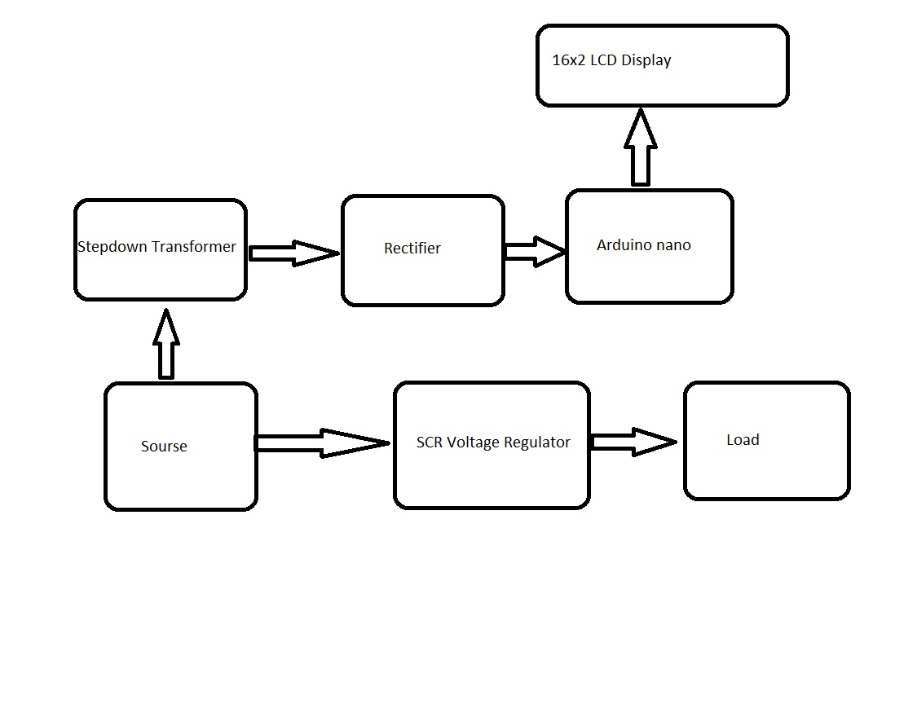

**DESCRIPTION OF BLOCK DIAGRAM:**

(1) AC Input: This is the input supply from the public utility where the device will be energized. It is also supplied directly to the relay contacts in the device which connects the load to the supply when the supply is within 200V – 240V range.

(2) Step down transformer: It steps down the AC supply into 12v on the secondary side. It is therefore a 230/12 v transformer. Any change in the primary reflects in the secondary of the transformer. So any fluctuations in the input is also reflected as a fluctuation in the output.

(3) Rectifier: A transformer, with single diodes for rectification is used to convert the ac voltage to a pulsating dc voltage followed by a filter, comprising of a capacitor to filter out (smooth) the pulsation. After the rectification and smoothening, a sample of the output voltage is fed to the Arduino. This voltage is unregulated and therefore varies as the input mains voltage varies. Since the system is to prevent against over voltage, the transformer was designed and the windings were so selected for the device to be able to sense and withstand input mains voltage up to 300Vac.

(4) Arduino: Arduino is an open-source prototyping platform based on easy-to-use hardware and software. Arduino boards are able to read inputs - light on a sensor, a finger on a button, or a Twitter message - and turn it into an output - activating a motor, turning on an LED, publishing something online. Arduino is the controller used in this project. It compares the input fluctuations with the preset value. If the fluctuations are within the limit then it makes the pin connected to the relay high. This trips the relay

(6) LCD Display: This displays the supply voltage as well as some information at “switch on” or when the supply voltage is out of range of the desired pre-set range of values. The LCD used is having a 16x 2 display.

**Circuit Diagram**

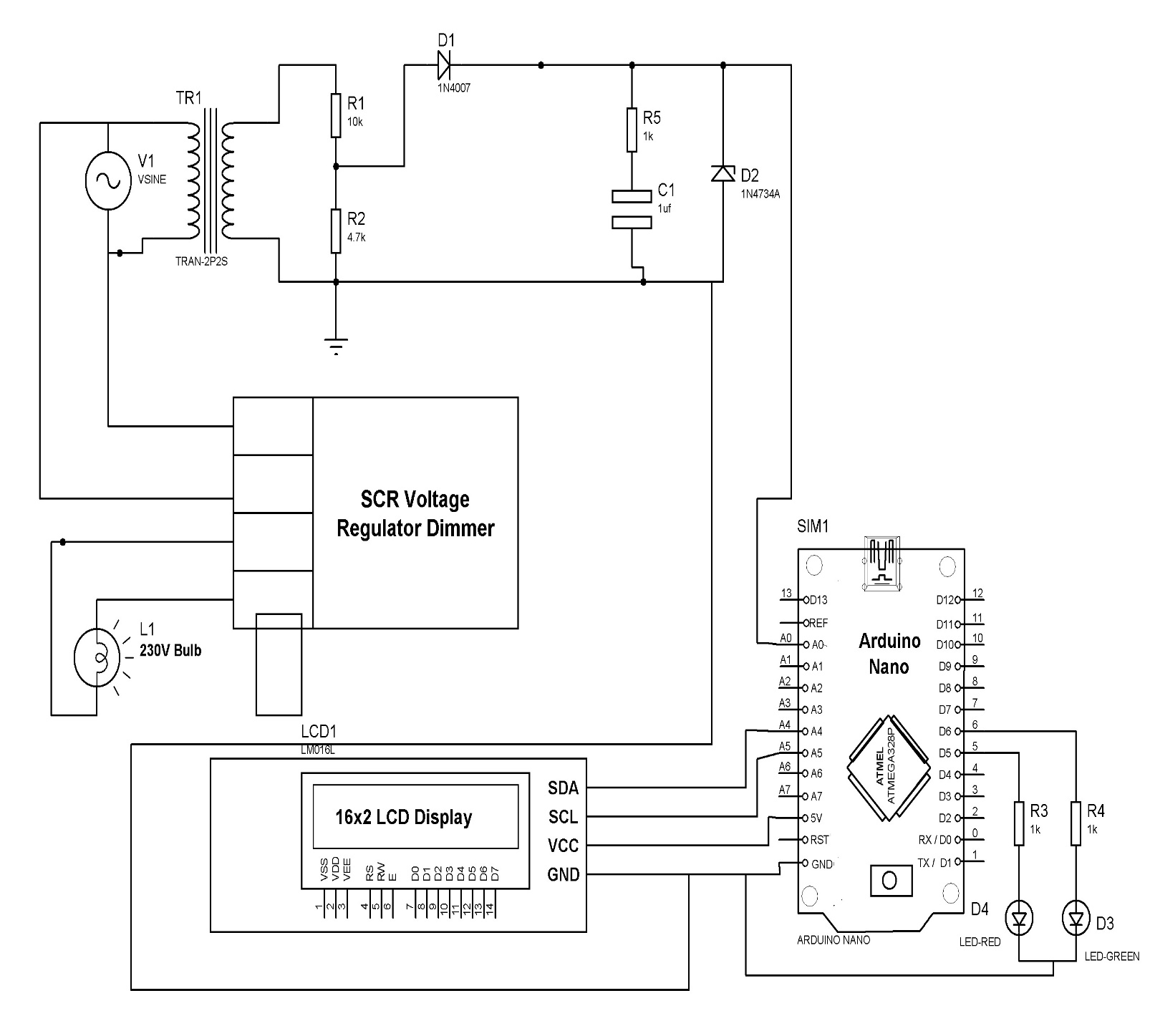

**OPERATION**

The ac supply at our homes is usually 230 V. Due to the fluctuations in load, it might vary. A tolerance of +2% is accepted. In case of increase in mains above 2%, the load might get damaged. rectifier converts the ac supply to dc. A filter comprising of a capacitor is connected to smoothen the pulsation. After the rectification and smoothening, a sample of the output voltage is fed to the Arduino. This voltage is unregulated and therefore varies as the input mains voltage varies. As the value of capacitance increases, the ripple content decreases. The capacitor used in this circuit is 1 micro farads. This is followed by a potential divider. The variable of the potential divider is connected to the input of the Arduino. Arduino has five analog input pins and 13 digital output pins. It has an inbuilt analog- digital converter. So, five different loads can be connected at a time. The 13 th pin contains a LED. Arduino takes an input voltage of 5-12 V and gives an output of 5 V or 3.3 V. A preset value with tolerance is given to the Arduino. The Arduino compares the preset value with the analog read value at A0.

If supply not given to system LCD Display on Supply not connected.if voltage voltage greater than threshold voltages then display over voltage detect. Also vary the intensity of bulb depending upon voltage level. We use voltage regulator module for vary voltage. Secondary side of transformer is 12V AC.so vary the voltage at primary side also deflect output at secondary side .this voltage given to arduino nano board Analog pin A0.Arduino process this signal & perform the operation depending upon programming.if voltage is greater than threshold voltage message shown on lcd display also red colour led on & normal opration green led on.we use I2C mudule for lcd display so we perform operation only four wire as shown on circuit diagram.Pin like VCC,GROUND,SDA,SCL.so reduce bunch of wire using I2C module